Math 3
Room 0304
Website: www.missschmucker.weebly.com
Email: sschmucker@wcpss.net
SUPPLIES:
Pencils
Graphing calculator TI-84
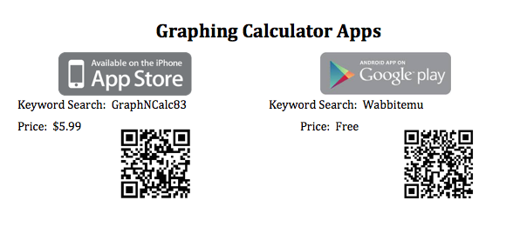
Every student is required to have a graphing calculator. If you do not have one, please try to purchase one as soon as possible. Please see me if you do not think you will be able to purchase one at this time or if you do not have a smartphone.
Please check places such as Office Stores, Amazon, Ebay, or Craig’s List for cheaper calculator purchase options!
It's completely worth the investment! I personally got a new Ti-84 in 9th grade, and that same calculator lasted me over 8 years!
If you have a smartphone, I highly encourage you to download the calculator app on your phone to use at home!

NOTEBOOK:
You will be required to keep an organized notebook for this course. They are very helpful for studying and review throughout the year. . Each notebook will need 6 tab dividers. On test days, notebooks will be evaluated for BONUS points.

Standard Based Grading:
Please visit my website: www.missschmucker.weebly.com for more details!

AFM 1 Grading Policy
Grading is currently moving toward 3 different categories that are the same across the Math Department. They are as follows:
Practice (Effort Grades – HW/CW):
- Usually 2 points each
- No Late Work Accepted
- Zeros given for no attempt
Process (Graded for Accuracy – Quizzes, Graded Assignments/Activities, Small Projects):
- Usually 10 – 50 points each
- Late Work only accepted 1 class period late for 65% credit
Product (Graded for Accuracy – Tests, Large Projects):
- Usually 55 – 100 points each
- Late work policy TBD per project*
*Teachers will agree on a common late work policy per project
CLASS EXPECTATIONS:
RESPECT yourself, others and your environment.
Arrive on time and prepared.
DO YOUR WORK!

