Advanced Functions and Modeling Unit 9: Phase Shifts

$y=a sin\left(bx+c\right)+d$ $y=a cos\left(bx+c\right)+d$
a = _________________ a = _________________
b = _________________ b = _________________
c = _________________ c = _________________
d = _________________ d = _________________
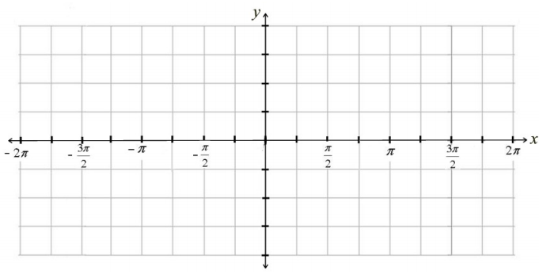
Parent Graph Parent Graph

Example 1: $y=2\sin\left(x-\frac{π}{4}\right)+1$
Amplitude ___________________
Period ______________________
Frequency ___________________
Phase Shift __________________
Vertical Shift _________________

Example 2: $y=\cos\left(2x-π\right)-2$
Factored Form
______________________
Amplitude ___________________
Period ______________________
Frequency ___________________
Phase Shift __________________
Vertical Shift _________________

Example 3: $y=\frac{1}{2}sin\left(4x-π\right)$
Factored Form
______________________
Amplitude ___________________
Period ______________________
Frequency ___________________
Phase Shift __________________

Can you write a function that meets the given conditions?
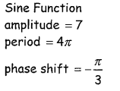
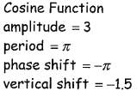
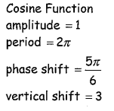
4. 5. 6.

