**Advanced Functions and Modeling Unit 9: Phase Shifts**



$y=a sin\left(bx+c\right)+d$ $y=a cos\left(bx+c\right)+d$

***a* = _________________ *a* = _________________**



***b* = _________________ *b* = _________________**



***c* = _________________ *c* = _________________**



***d* = _________________ *d* = _________________**



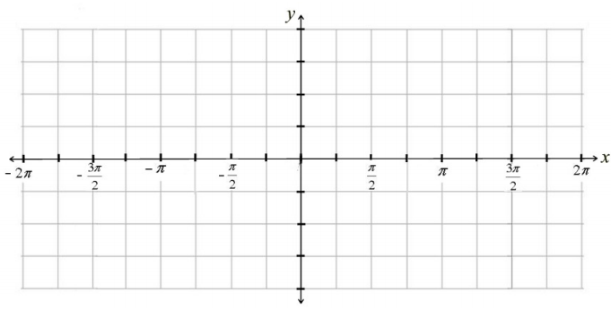**Parent Graph Parent Graph**



**Example 1: $y=2\sin\left(x-\frac{π}{4}\right)+1$**



Amplitude ___________________

Period ______________________



Frequency ___________________



Phase Shift __________________



Vertical Shift _________________

**Example 2: $y=\cos\left(2x-π\right)-2$**



**Factored Form**

**______________________**



Amplitude ___________________



Period ______________________



Frequency ___________________



Phase Shift __________________



Vertical Shift _________________



**Example 3: $y=\frac{1}{2}sin\left(4x-π\right)$**

**Factored Form**



**______________________**



Amplitude ___________________



Period ______________________



Frequency ___________________



Phase Shift __________________

**Can you write a function that meets the given conditions?**

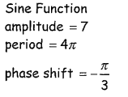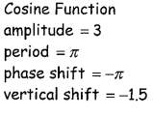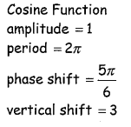4. 5. 6.

