Name _____________________________________________________ Period ________ Date ________________
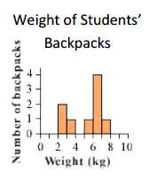
Advanced Functions and Modeling Unit 6 Homework 1
1. The histogram shows a set of data of backpack weights.
a. How many backpacks are between 2kg and 3kg?

b. How many values are in the data set?

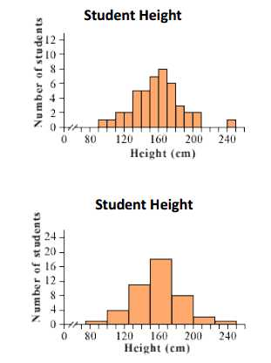
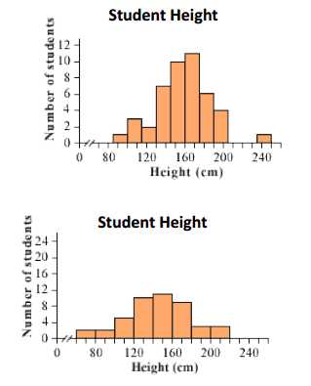
2. Study these four histograms.

a. What is the bin width of each histogram?

b. Which histogram could not have come from the same data set as the other three? Explain your answer.

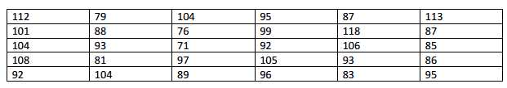
3. The golf scores for the first 30 golfers of the Belmont Country Club are below. Construct a frequency table and histogram on a separate sheet of paper.

4. Ignacio kept a log of the amount of time he spent doing homework and the amount of time he spent watching television.
Day | 1 | 2 | 3 | 4 | 5 | 6 | 7 | 8 | 9 | 10 | 11 | 12 | 13 | 14 | 15 | 16 | 17 | 18 | 19 | 20
HW (min) | 4 | 10 | 40 | 11 | 55 | 46 | 46 | 23 | 57 | 28 | 65 | 58 | 52 | 38 | 38 | 39 | 45 | 27 | 41 | 44
TV (min) | 78 | 30 | 15 | 72 | 25 | 30 | 90 | 40 | 35 | 56 | 12 | 5 | 95 | 27 | 38 | 50 | 10 | 42 | 60 | 34

a. Create two histograms (on a separate sheet of paper), one showing the amount of time spent doing homework, and one showing the amount of time watching television. Then decide which distribution has greater variation.

b. Does Ignacio watch television the same amount of time he does homework? If no, what conclusion can you make based on the data give. Explain your reasoning.

Sum | Frequency
2 | 26
3 | 56
4 | 83
5 | 110
6 | 145
7 | 162
8 | 149
9 | 114
10 | 73
11 | 61
12 | 21
5. Carl and Bethany roll a pair of dice 1000 times and keep track of the sum on the two dice. The frequency of each sum is listed below.

a. Graph the histogram using a bin width of one.

b. Explain why the shape of the histogram is mound-shaped.

