Name __________________________________________________ Period _________ Date ____________
Advanced Functions and Modeling Unit 9 Homework 1
Graph the parent sine function and the transformed sine function. State the period and the amplitude the for the transformed function.
1. $y=3\sin{x}$ 2. $y=-2\sin{x}$

3. $y=\sin{4x}$ 4. $y=\sin{\frac{1}{2}x}$

5. $y=1+ sin{x }$ 6. $y=\sin{x-2}$

7. $y=2\sin{2x}$ 8. $y=-\sin{x+3}$

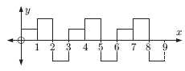
Which of these graphs show periodic behavior?
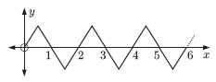
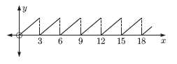
9. 10. 11.

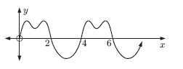
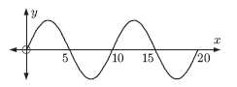
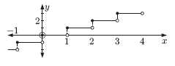
12. 13. 14.

Find the formula in the form $y=a\sin{bx}+c$ which produces the following graphs.
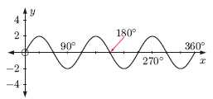
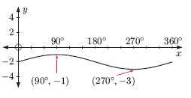
15. 16.

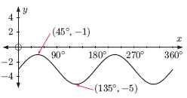
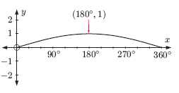
17. 18.

