Name ______________________________________________________ Period _______ Date ______________
AFM Unit 6 Homework 2
Find the mean, median, semi-quartile range, interquartile range, outliers, and standard deviation for each set of data. Construct a box-and-whiskers plot (including outliers) for each set of data. Describe the shape of each graph.
1. 43, 26, 92, 11, 8, 49, 52, 126, 86, 42, 63, 78, 91, 79, 86

2. 149, 289, 121, 146, 212, 98, 86, 153, 128, 136, 181, 142

3. 26.8, 15.7, 98.4, 27.3, 14.1, 81.6, 19.4, 21.5, 46.5, 23.7, 16.7, 29.8

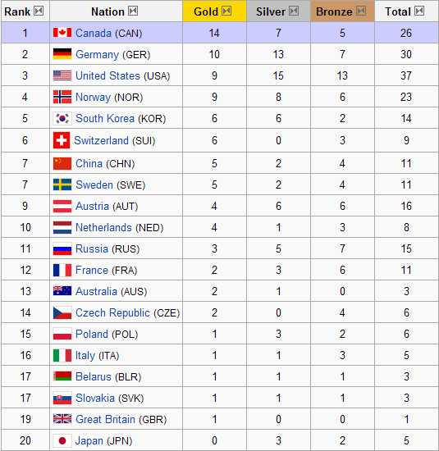
4. The medals won by the top 20 countries at the 2010 Winter Olympic Games in Vancouver.

a. Find the range, mean, interquartile range, and standard deviation for number of gold medals.

b. Find the range, mean, interquartile range, and standard deviation for number of silver medals.

c. Which set of data demonstrated greater variability: gold or silver. Explain what that means.

