Name ______________________________________________________ Period _________ Date ______________

**Advanced Functions and Modeling Unit 8 Homework 2**

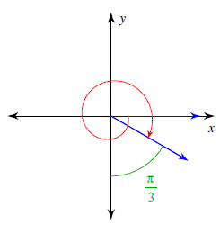**Find each angle measure.**

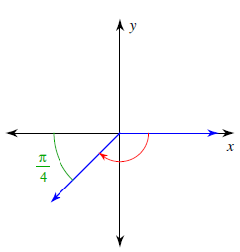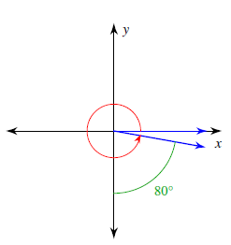1. 2. 3.

**Draw an angle with the given measure in standard position.**

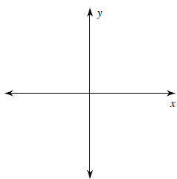4.  5.  6. 

**State the quadrant in which the terminal side of each angle lies.**

7.  8.  9.  10. 

**Find the coterminal angle between and .**

11.  12.  13.  14. 

**Find the coterminal angle between and .**

15.  16.  17.  18. 

**Find two positive and two negative coterminal angles for each angle measure.**

19.  20.  21.  22. 

|  |  |  |
| --- | --- | --- |
| **Central Angle is in….** | **Radians** | **Degrees** |
| **Arc Length** | $$θr$$ | $$\frac{θπr}{180}$$ |
| **Sector Area** | $$\frac{θr^{2}}{2}$$ | $$\frac{θπr^{2}}{360}$$ |

**WORKING WITH FORMULAS**

1. Find the arc length and sector area of a circle with a radius length of 8 and a central angle measure of .

2. Find the arc length and sector area of a circle with a radius length of 5 and a central angle measure of .

3. If the sector area of a circle is 54 cm2, and the central angle is $45°$, find the length of the radius.