Name ___________________________________________________ Period ____________ Date ________________

**Advanced Functions and Modeling Unit 9 Homework 2**

**For each problem, graph both the parent function ($y=\cos{x}$) and the transformed function.**

1. 2.



3. 4.

5. 6.

**Without graphing, state the period of each function.**

7. 8. 9.

**Write the function for each cosine graph.**

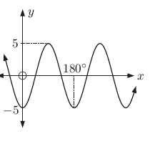10. 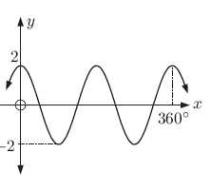 11. 12. 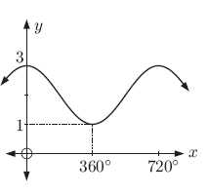

**Graph each of the functions.**

13. 14.

