Name ____________________________________________________ Period ________ Date ________________
Advanced Functions and Modeling Unit 9 Homework 3
Using the graph, determine the amplitude, period, frequency, and vertical shift for each graph. Then write the function.
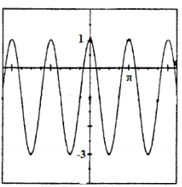
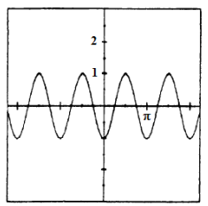
1. 2.

Amplitude ___________ Amplitude ___________
Period ____________ Period ____________
Frequency ____________ Frequency ____________
Vertical Shift __________ Vertical Shift __________
Cosine Function _______________________ Cosine Function _______________________

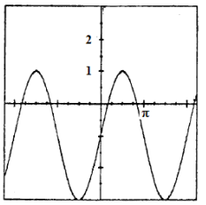
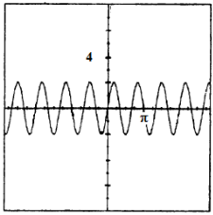
3. 4.

Amplitude ___________ Amplitude ___________
Period ____________ Period ____________
Frequency ____________ Frequency ____________
Vertical Shift __________ Vertical Shift __________
Sine Function _______________________ Sine Function _______________________
Identify the amplitude, period, phase shift, and/or vertical shift. Graph the function before and after the phase shift.
5. $y=3\sin\left(x-π\right)+1$ 6. $y=-\cos{(2x+π)}$
Amplitude _______________ Period _____________ Amplitude _______________ Period _____________
Phase Shift ______________ Vertical Shift ________ Phase Shift ______________ Vertical Shift ________
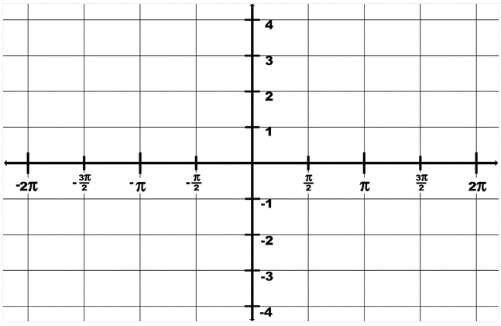

7. $y=2\sin\left(x+\frac{π}{2}\right)-2$ 8. $y=2\cos\left(\frac{1}{2}x-\frac{π}{2}\right)$
Amplitude _______________ Period _____________ Amplitude _______________ Period _____________
Phase Shift ______________ Vertical Shift ________ Phase Shift ______________ Vertical Shift ________

