Name ________________________________________________ Period ________ Date ________________

**Advanced Functions and Modeling Unit 8 Homework 3**

**Find the exact value of each trigonometric function. It may be necessary to first find the coterminal angle that lies between $0°$ and or and .**



1. 2. 3. 4.



5. 6. 7. 8.



9. 10. 11. 12.



13. 14. 15. 16. $\csc{945°}$



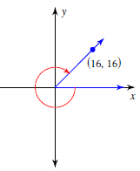**Use the Pythagorean Theorem to find the exact value of the trigonometric function**.



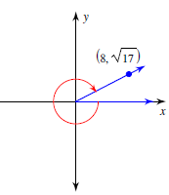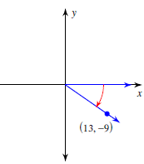17. $\sin{θ}$ 18. $\cos{θ}$ 19. $\csc{θ}$

