Name _________________________________________________ Period ________ Date _______________
Advanced Functions and Modeling Unit 11 Homework 3
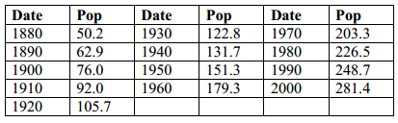
1. The following table gives the resident population of the USA from 1790 to 2000 in millions of people.

a. Give mathematical evidence that the growth of population is roughly exponential. (Find r values of different models or look at shape of graph.)

b. Find a regression formula that predicts the population. ____________________________
c. Find the residual for this formula for the year 2000. ______________________
d. Predict the U.S. population for the year 2010. Is your confidence high, medium, or low for this calculation? Explain.

2. We wish to predict the lifespan (years) of various mammals based on the weight in pounds. Following is a chart of body weight and avg. lifespan for several species of mammals. Input the data into your calculator.
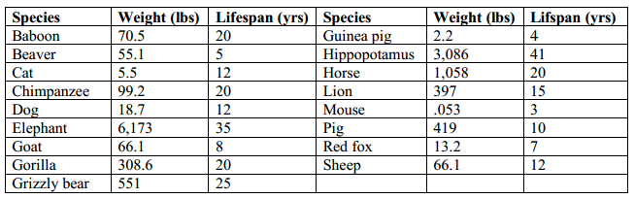
a. Explain why an exponential model doesn’t fit the data.

b. Find a power model to fit the data.

c. Predict the lifespan of a tiger (400 pounds) and a grey whale (35 tons) using this formula.

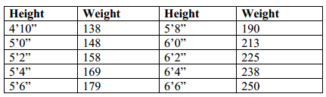
3. The U.S. Department of Health and Human Services characterizes adults as seriously overweight if they meet the weight criterion for their height. The data is for both genders.

a. Explain why a power model makes sense for this data based on the fact that you are measuring height and weight.

b. Generate a power model to predict the “seriously overweight” figure based on a person’s height.

c. According to your formula, what would a 5’10” person have to weigh in order to be classified as seriously overweight? How about a 7 foot person?

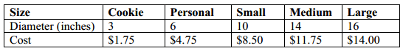
4. Angelo’s Pizza has 5 sizes of pizza. Rather than offering slices of pizza, they have a pizza called “cookie size”. The size and prices of their pizzas are in the chart below:

a. Generate a linear regression model, an exponential model, and a power model for diameter vs. cost.
Linear: __________________ Exponential: __________________ Power: __________________
b. If Angelo’s has a new pizza size called a “mini” (8 inch diameter) , how much does each model suggest they should charge for it?
Linear: __________________ Exponential: __________________ Power: __________________
c. If Angelo’s has a new pizza size called a “Oh-My-God” (42 inch diameter), how much does each model suggest they should charge for it?
Linear: __________________ Exponential: __________________ Power: __________________
d. Which model makes the most sense and why?

