Name _________________________________________________ Period _______ Date ________________
Advanced Functions and Modeling Unit 6 Homework 3
For each situation, label the normal curve and answer the corresponding questions.
1. Two thousand freshman at NC State took a Biology test. The scores were distributed normally with a mean of 70 and a standard deviation of 5.
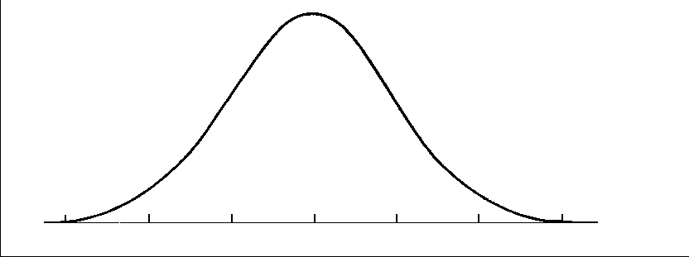
a. What percentage of scores are between…
65 and 75? ___________ 60 and 70? ___________ 60 and 85? ___________ less than 55? ___________
b. Approximately how many Biology students scored between…
60 and 70? ___________ 55 and 60? ___________

2. Five hundred juniors took the ACT last year at Broughton. The scores were normally distributed with a mean of 24 and a standard deviation of 4.

a. What percentage of scores are between…
20 and 28? ___________ 16 and 32? ___________ 16 and 28? ___________ greater than 24? ___________
b. Approximately how many juniors scored between…
24 and 28? ___________ 24 and 32? ___________ 16 and 20? ___________ higher than 32? ___________
3. Below are the scores on a recent exam given in a college statistics course.
90 90 95 100 80 80 75 80 70 60 95 100 100
100 75 80 90 90 90 70 70 80 85 90 90 85
a. Find the following statistical summaries.
Mean __________ Median __________ Mode __________ Standard Deviation __________
b. Draw the normal distribution curve.

c. How many scores are within one standard deviation of the mean? ________________________
d. How many scores are within two standard deviations of the mean? ________________________

4. SAT scores are distributed normally with a mean of 1500 (sum of all three sections) and a standard deviation of 300. Act scores are distributed near normal with a mean of 21 and a standard deviation of 5. A college admissions officer wants to determine which of the two applicants scored better: Pam, who earned an 1800 on her SAT, or Jim, who scored a 24 on his ACT? Sketch both curves. Label where Jim and Pam fall on the curve. Then find the z-scores for both and use it to determine whose score is “better.”

