Name ________________________________________________ Period ________ Date ________________
Advanced Functions and Modeling Unit 8 Homework 3
Find the exact value of each trigonometric function. It may be necessary to first find the coterminal angle that lies between $0°$ and $360°$ or $0$ and .
1. $\cos{60°}$ 2. $\sin{225°}$ 3. $\cos{\frac{5π}{6}}$ 4. $\sin{90°}$

5. $\tan{225°}$ 6. $\sin{\frac{7π}{3}}$ 7. $\tan{\frac{π}{4}}$ 8. $\cos{π}$

9. $\cos{-630°}$ 10. $\sin{990°}$ 11. $\tan{-\frac{13π}{6}}$ 12. $\csc{\frac{17π}{3}}$

13. $\sec{\frac{11π}{2}}$ 14. $\sin{-2π}$ 15. $\cot{\frac{5π}{6}}$ 16. $\csc{945°}$

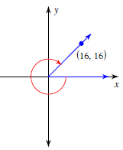
Use the Pythagorean Theorem to find the exact value of the trigonometric function.
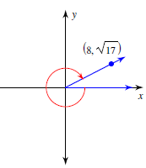
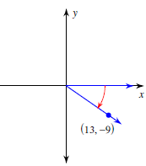
17. $\sin{θ}$ 18. $\cos{θ}$ 19. $\csc{θ}$

