Name ____________________________________________________ Period _____ Date __________
Advanced Functions and Modeling Unit 7 Homework 4
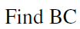
Find each measurement. SHOW YOUR WORK! Round your answers to the nearest tenth.
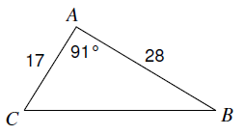
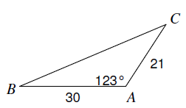
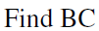
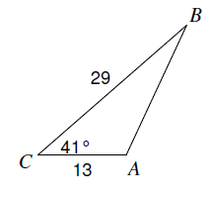
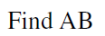
1. 2. 3.

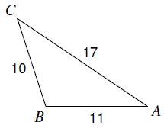
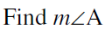
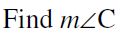
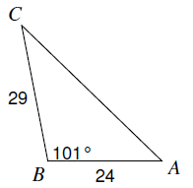
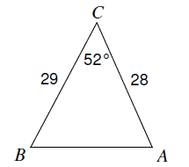
4. 5. 6.

Solve each triangle. Show your work. Draw a picture where necessary. Round answers to the nearest tenth.
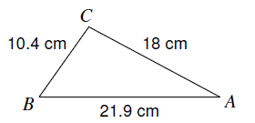
7. 8.

$m∠A=_____$ $m∠B=_____$ $m∠C=_____$ $m∠Y=_____$ $m∠Z=_____$ $x=_____$

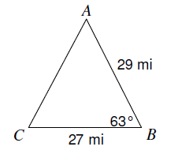
9. 10.

$m∠P=_____$ $m∠Q=_____$ $r=_____$ $m∠A=_____$ $m∠C=_____$ $b=_____$

