Name _________________________________________________ Period _________ Date ___________________
Advanced Functions and Modeling Unit 10 Homework 4
Write a polynomial function in standard form with the given zeros.
1. $-5, 3, 0$ 2. $7i, -7i$; reflected over 3. $i, -i, 2$
the x-axis

4. $-2 (multiplicity of 3)$ 5. $3, 4 (mulitplicity of 2)$; reflected over the x-axis

Assuming a leading coefficient of 1, all real zeros, and multiplicities of 1 – 3, write the polynomial function using the zeros from the graph.
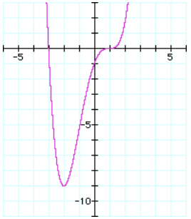
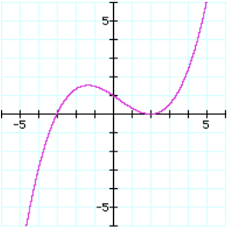
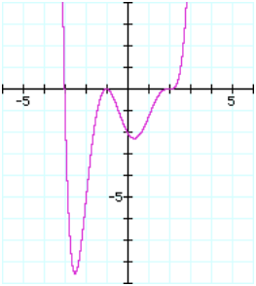
6. 7. 8.

