Advanced Functions and Modeling Unit 7 Homework 1
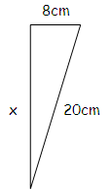
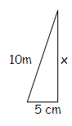
First, use the Pythagorean Theorem to find the exact value of the missing side of the right triangle. Second, find the exact ratios of the six trigonometric ratios.
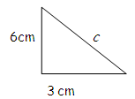
1. 2. 3.

$\sin{θ}=$ $\csc{θ= }$ $\sin{θ}=$ $\csc{θ= }$ $\sin{θ}=$ $\csc{θ= }$
$\cos{θ}=$ $\sec{θ= }$ $\cos{θ}=$ $\sec{θ= }$ $\cos{θ}=$ $\sec{θ= }$
$\tan{θ}=$ $\cot{θ= }$ $\tan{θ}=$ $\cot{θ= }$ $\tan{θ}=$ $\cot{θ= }$

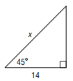
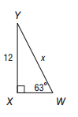
Find the missing value in each triangle. Show the set up for problem. Round each answer to the nearest hundredth.
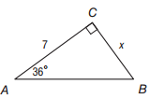
4. 5. 6.

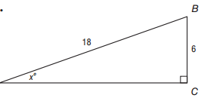
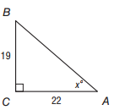
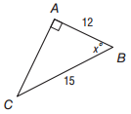
7. 8. 9.

Use the given trigonometric ratio to find the other five trigonometric ratios. Then find the measure of $θ$.
10. $\sec{θ=\frac{13}{5}}$ $θ=$ 11. $\cot{θ= \frac{1}{8}}$ $θ=$ 12. $\sin{θ= \frac{\sqrt{2}}{2}}$ $θ=$
$\sin{θ}=$ $\csc{θ= }$ $\sin{θ}=$ $\csc{θ= }$ $\sin{θ}=\frac{\sqrt{2}}{2}$ $\csc{θ= }$
$\cos{θ}=$ $\sec{θ= \frac{13}{5}}$ $\cos{θ}=$ $\sec{θ= }$ $\cos{θ}=$ $\sec{θ= }$
$\tan{θ}=$ $\cot{θ= }$ $\tan{θ}=$ $\cot{θ= \frac{1}{8} }$ $\tan{θ}=$ $\cot{θ= }$
Advanced Functions and Modeling Unit 7 Homework 2
For each problem, draw a picture and write the trigonometric equation required to solve. Round answers to the nearest hundredth.
1. The cloud ceiling is the lowest altitude at which solid cloud is present. If the ceiling is too low, airplanes cannot take off. One way meteorologists can find the cloud ceiling at night is to shine a searchlight straight up and observe the spot of light on the clouds from a location away from the searchlight. If the searchlight is located 200 meters from the meteorologist and the angle of elevation to the spot of the light on the clouds is $35°$, how high is the cloud ceiling?

2. Jodie and Amy are in Chicago for the weekend. Suppose Jodie is on the Skydeck of the Sears Tower (103rd floor, 1335 ft above the ground) looking through a telescope at Amy who is on the Observation Deck at the John Hancock Building, which is on the 94th floor, 1030 ft above the ground. . Amy is also looking through a telescope back at Jodie. The two buildings are 8976 ft apart. What is the angle of elevation from Amy to Jodie?

3. A salvage ship’s sonar locates wreckage at a 12$°$ angle of depression. A diver is lowered 40 meters to the ocean floor. How far does need to walk across the ocean floor to reach the wreckage?

4. A fourteen-foot ladder is used to scale a thirteen-foot wall. At what angle of elevation must the ladder be placed with the ground to reach the top of the wall?

5. Standing on a cliff 380 meters above the sea, Pat sees an approaching ship and measures its angle of depression, obtaining 9 degrees. How far from shore is the ship? Now Pat sights a second ship beyond the first. The angle of depression of the second ship is 5 degrees. How far apart are the ships?

6. Jeff is watching a space shuttle launch, andspots the shuttle at angle of elevation of 75$°$. Jeff is 6’ tall, and spots the shuttle as it reaches 1000 ft. How far is Jeff from the launch site?

7. Sarah flies a kite. If she lets out 15 feet of string at a 60$°$ angle, how high in the air is the kite? Sarah is 5’9”.

