Name ___________________________________________________ Period ____________ Date ________________

**Advanced Functions and Modeling Unit 9 Homework 2**

**For each problem, graph both the parent function ($y=\cos{x}$) and the transformed function.**

1. 2.







3. 4.



5. 6.



**Without graphing, state the period of each function.**



8. 9.



**Write the function for each cosine graph.**



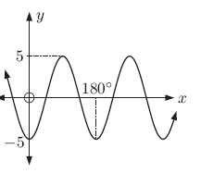10. 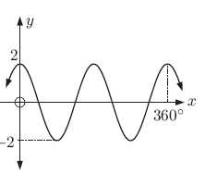 1. 12. 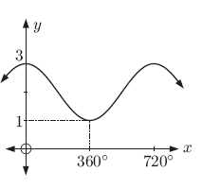



**Graph each of the functions.**



13. 14.





