Name ____________________________________________ Period ________ Date ________________
Advanced Functions and Modeling Unit 7 Homework 6
Find the area of each triangle. Show the set up of the problem. Round to the nearest tenth.
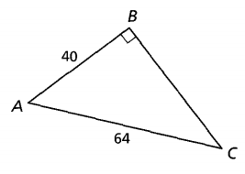
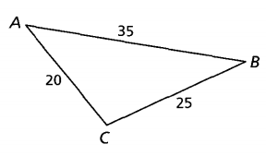
1. 2.

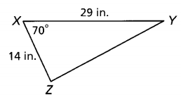
A triangular plot of land has side lengths 65 ft, 74 ft, and 101 ft. Find the area of the land.
3. 4.

Use the Law of Sines to find the necessary side measure needed to find the area. Then find the area.
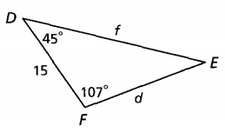
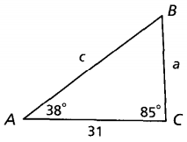
5. 6.

