Name ___________________________________________________ Period ___________ Date _________________
Advanced Functions and Modeling Unit 9 Test Review
Amplitude
Period
Vertical Shift
Phase Shift
Frequency

I. Graphing
Graph each of the following. State the amplitude, period, and any shifts.
1. $y=-2\sin{x+1}$ 2. $y=3\sin{\frac{1}{2}x}$

3. $y=-4\cos{2x}$ 4. $y=2\cos\left(2x-\frac{π}{2}\right)-1$

II. Writing Equations of Graphs
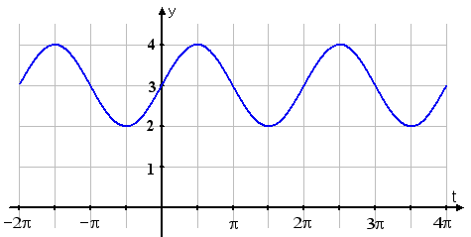
Write the equation for each sine or cosine graph below.
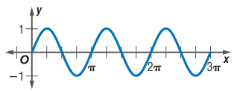
1. 2.

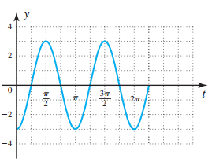
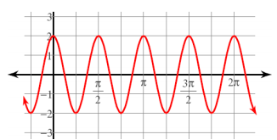
3. 4.

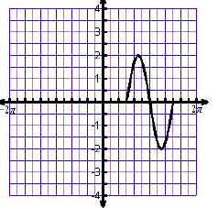
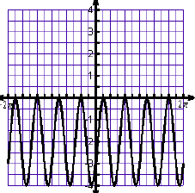
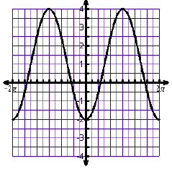
5. 6. 7.

8. Write a sine function with an amplitude of 5, reflected over the x-axis, with a period of $\frac{π}{2}$ , shift down 2 units.

9. Write a sine function with an amplitude of 2, period of $5π$, phase shift left $\frac{π}{4}$ , and vertical shift upward of 3.

III. Modeling and Applications of Sine and Cosine
1. Suppose the length of time between consecutive high tides is approximately 12.5 hours. On Saturday, June 28, 1997, in Juneau, Alaska, high tide occurred at 8:11 am and low tide occurred at 2:14 pm. The height of the water at high tide was 13.2 feet and the height at low tide was 2.2 feet.
a. Find the amplitude, vertical shift, and period.

b. Write a cosine function. c. Find the height of the tide at 10 am and at 7 pm.

2. A Ferris wheel is 50 meters in diameter and boarded at the six o’clock position on a platform that is 4 meters above the ground. The wheel completes one full revolution every 12 minutes. At t = 0, you are at the three o’clock position and ascending.
a. Sketch a Ferris wheel and label. b. Write a cosine function.

c. Predict the height above the ground after 6.5 minutes. d. Use a graph to predict when you are 18 meters above ground.

