Name __________________________________________________ Period ___________ Date _______________
Advanced Functions and Modeling Unit 7 Test Review
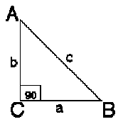
1. Find the six trigonometric ratios for angle A. Answers should be exact – no decimals.
Then find the measures of the angles and round to the nearest tenth.

a. $a=2, c=6$ b. $a=3, b=6$

2. Using the same triangle as above, answer the following:
a. If $∠B=49°$ and $b=9$, find $a$. b. If $∠A=65°$ and $a=15$, find $c$.

c. If $a=21$ and $b=13$, find $m∠A$. d. If $a=4.5$ and $c=7.2$, find $m∠B$.

3. If $\sin{θ=\frac{7}{25}}$ , find the $\cot{θ}$ and the measure of $θ$.

4. Sam is driving to Nashville through the Appalachian Mountains. He passes the sign below on his way up
the side of the mountain. “9% grade” means that for each 100 feet of horizontal length, the ground rises 9 feet
vertically. Sam drives the entire 7 miles up the side of the mountain. (“7 miles” is the length of the actual road
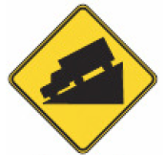
he drives.)

a. How many feet does he actually drive? (5280 feet = 1 mile)?

b. If a (different) hill with 9% grade is exactly 100 feet horizontally, how long is the actual road up the side of that hill?
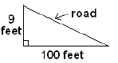

c. What is the angle of elevation of the road?

Use the Laws of Sines and Cosines to solve each triangle. Then find the area of each triangle.
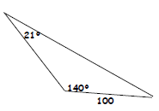
5. 6. $a=36 cm, b=50 cm, m∠B=75°$

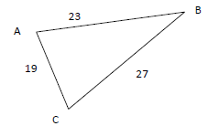
7. $a=17 in, b=26 in , m∠C=124°$ 8.

Use either the Law of Sines or Cosines to solve. Draw a picture. Round answers to the nearest tenth.
9. Two ships leave a harbor at the same time, traveling on courses that have an angle of 140 degrees between them. If the first ship travels at 26 miles per hour and the second ship travels at 34 miles per hour, how far apart are the two ships after 3 hours?

10. An isosceles triangle has a base of 22 centimeters and a vertex angle of 36⁰. Find the perimeter of the triangle.

