STATISTICS: SHAPES OF GRAPHS
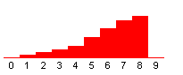  LEFT-SKEWED  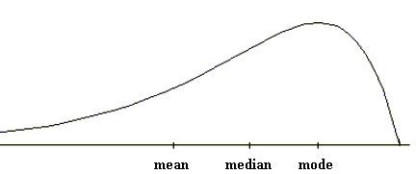 | RIGHT-SKEWED  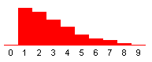  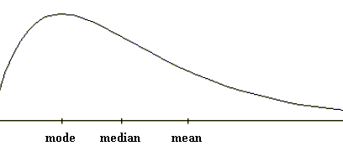
OTHERS  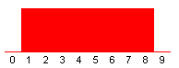  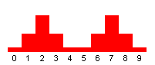  UNIFORM  SYMMETRIC  BIMODAL  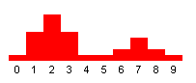  NON-  SYMMETRIC  BIMODAL | SYMMETRIC (UNIMODAL)  (NORMAL DISTRIBUTION)  