

**Ex :** Find the relative maximum and relative minimum of .

Relative Maximum: _______ Relative Minimum: _______

**Points of Inflection**

**Def:** A point at which the function of the graph changes ________________.

A cubic polynomial has _____ inflection point. A 4th degree polynomial has ____ inflection points. Quadratic and linear functions have ____ inflection points.

**End Behavior**

1. If the degree of a polynomial is _________, then the arms of the graph are either both ________ or __________.
2. If the degree is ________, then one arm of the graph is _____ and the other is _______.
3. If the leading coefficient is _______________, the right arm of the graph is ________.
4. If the leading coefficient is ______________, the right arm of the graph is ___________.



**Increasing/Decreasing**

**Ex** : Describe the intervals over which the graph is increasing and decreasing for .

Intervals: ____________________

**Practice Problem: (Putting it all together! ☺)**

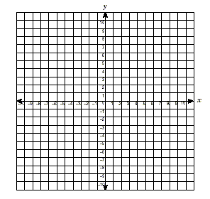 

Relative Max: _____________

Relative Min: ______________

Inc/Dec Intervals: ______________

Zero(s): _______________

End behavior: _______________