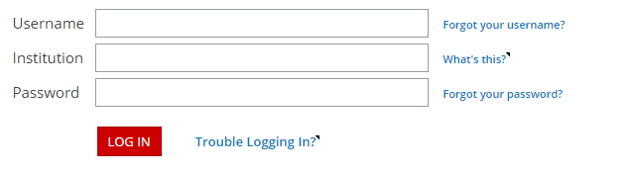
STUDENT ID
broughton.nc
STUDENT ID
http://webassign.net

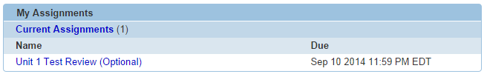
Begin Assignment

- If you have multiple classes, you will need to select the class from the top left, then select the assignment.
- Webassigns are always due at 11:59 PM the night before your unit test.
- You have two tries for each question.
- Because this is extra credit, no extensions will be granted.
- Don’t forget to SUBMIT ASSIGNMENT when finished.
- Extra credit will be awarded based on percent correct. (Example: 93.4% = 9.3 points of extra credit)

STUDENT ID
broughton.nc
STUDENT ID
http://webassign.net

Begin Assignment

- If you have multiple classes, you will need to select the class from the top left, then select the assignment.
- Webassigns are always due at 11:59 PM the night before your unit test.
- You have two tries for each question.
- Because this is extra credit, no extensions will be granted.
- Don’t forget to SUBMIT ASSIGNMENT when finished.
- Extra credit will be awarded based on percent correct. (Example: 93.4% = 9.3 points of extra credit)

